AnaCap R-Test Answers

# Answer 1:

<https://github.com/vishalsharma3003/Anacap>

All the code can be seen here. Please read the read.md file for more information

# Answer 2:

Summary of RProf is below:

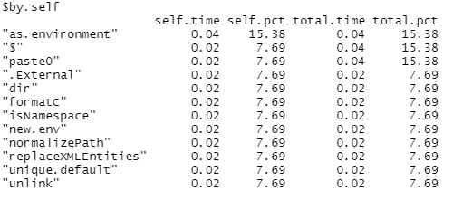

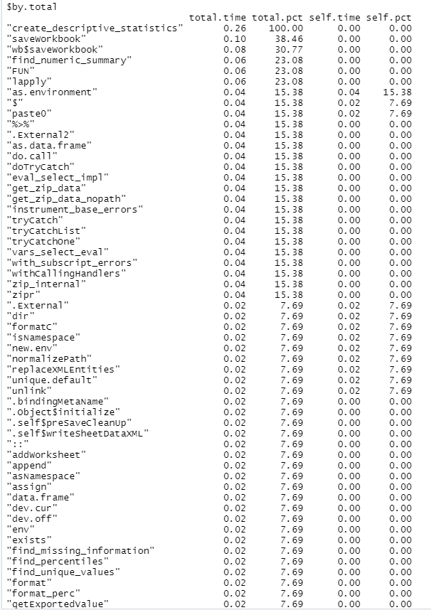

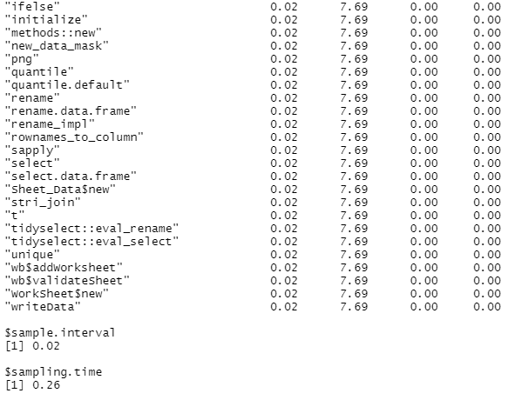

# Answer 3:

I have tried to create maximum functions which can be re-used for example the function for finding the missing values was used in both Overall tab and Numeric tab. However, there is still a lot of potential for creating more functions and reduce the repetitive code.

When it comes to scalability, the code is easily scalable but for it to be more scalable, there could have been modules which were doing the specific tasks. Creating modules in R makes the code highly scalable and so different users can easily work upon those modules.

Although the code lacks a lot of comments but I skipped them because of the deadline.

# Answer 4:

While running the code, once the error is thrown in the console, we can use the “show traceback” to see how the function was executed and from where the error was thrown. For example:

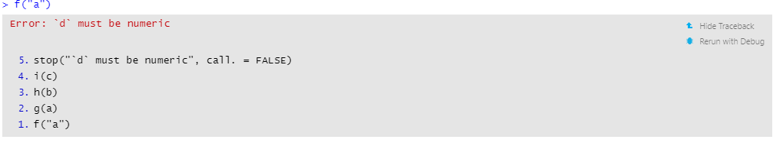

To debug the code, we can place a debug point at the first function

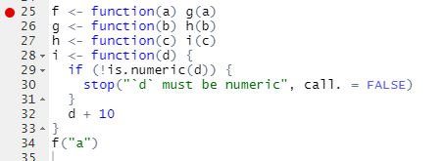

And then re-run the code with Debug and see the values.

We can also use this traceback in debug mode:

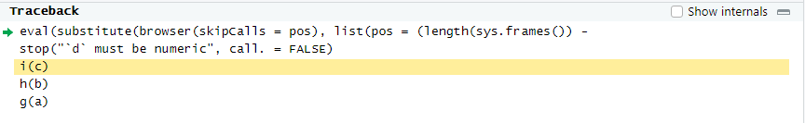

The error can be fixed either by passing the numeric value in the f function like:



Or we can create an if inside the ‘i()’ function so that if the value is non numeric then it does something else like append the character 10 times. For example:

